**C-DAC Mumbai Date 25/09/2024**

**Subject: Algorithm and Data Structure**

**Assignment 1**

**Solve the assignment with following thing to be added in each question.**

-Program

-Flow chart

-Explanation

-Output

-Time and Space complexity

1. Armstrong Number

Problem: Write a Java program to check if a given number is an Armstrong number.

Test Cases:

Input: 153

Output: true

Input: 123

Output: false

Code:

import java.util.Scanner;

public class Main {

public static void main(String[] args) {

Scanner sc = new Scanner(System.in);

System.out.print("Enter a number: ");

int number = sc.nextInt(); // Input number from the user

int originalNumber = number; // Store original number

int sum = 0; // Variable to store the sum of digits raised to the power of the number of digits

// Calculate the number of digits

int digits = String.valueOf(number).length();

// Calculate the sum of the digits raised to the power of the number of digits

while (number > 0) {

int digit = number % 10; // Get the last digit

sum += Math.pow(digit, digits); // Raise it to the power of digits and add to sum

number /= 10; // Remove the last digit

}

// Check if the original number is equal to the sum

if (sum == originalNumber) {

System.out.println(originalNumber + " is an Armstrong number.");

} else {

System.out.println(originalNumber + " is not an Armstrong number.");

}

sc.close(); // Close the scanner

}

}

**Time Complexity:**

* **O(d)**: The time complexity is linear in terms of the number of digits d in the input number since we process each digit once.

**Space Complexity:**

* **O(1)**: The space complexity is constant as we are using a fixed amount of space regardless of the input size.

Start

|

V

Input number

|

V

Store original number

|

V

Count the number of digits

|

V

Initialize sum to 0

|

V

While number > 0:

|--> Get last digit

|--> Add digit^number_of_digits to sum

|--> Remove last digit

|

V

If sum == original number

|--> Print "is an Armstrong number."

|

Else

|--> Print "is not an Armstrong number."

|

V

End

**Explanation:**

1. The program prompts the user to enter a number.
2. It stores the original number for comparison later.
3. It calculates the number of digits in the input number.
4. The program then uses a loop to extract each digit, raise it to the power of the number of digits, and accumulate this value into a sum.
5. After exiting the loop, it compares the sum with the original number.
6. If they are equal, it indicates that the number is an Armstrong number; otherwise, it indicates that it is not.

2. Prime Number

Problem: Write a Java program to check if a given number is prime.

Test Cases:

Input: 29

Output: true

Input: 15

Output: false

Code:

package Monu;

import java.util.*;

public class Factorial {

    public static void main(String[] args) {

        Scanner sc = new Scanner(System.in);

        // Input number from the user

        System.out.print("Enter a number: ");

        int number = sc.nextInt();

        // Check if the number is prime

        if (isPrime(number)) {

            System.out.println(number + " is a prime number.");

        } else {

            System.out.println(number + " is not a prime number.");

        }

        sc.close();

    }

    private static boolean isPrime(int number) {

      if(number <=1){

        return false;

      }

      for(int i =2;i<number;i++){

        if(number%i==0){

            return true;

        }

      }

      return true;

    }

    }

**Explanation:**

* **Input:** Accepts an integer input from the user.
* **Prime Check Logic:**
  + If the number is less than or equal to 1, it is not prime.
  + For numbers greater than 1, it checks if the number is divisible by any number between 2 and the square root of the number. If a divisor is found, it is not prime.
  + If no divisors are found, the number is prime.

Flowchart:

Start

↓

Input Number

↓

Is Number <= 1?

/ \

Yes No

↓ ↓

False Check divisibility from 2 to √n

↓

Is divisible by any number?

/ \

Yes No

↓ ↓

False True

* **Time Complexity**: O(√n), since we only check divisibility up to the square root of the number.
* **Space Complexity**: O(1), as we only use a constant amount of space.

3. Factorial

Problem: Write a Java program to compute the factorial of a given number.

Test Cases:

Input: 5

Output: 120

Input: 0

Output: 1

Code:

package Monu;

import java.util.*;

public class Factorial {

        public static void main(String[] args) {

            Scanner sc = new Scanner(System.in);

            // Input number

            System.out.print("Enter a number: ");

            int num = sc.nextInt();

            // Compute factorial

            System.out.println("Factorial of " + num + " is: " + factorial(num));

            sc.close();

        }

      public static int factorial(int num) {

        if (num == 0 || num == 1) {

            return 1;

        }

        return num * factorial(num - 1);

    }

}

**Assignment 1 Solution**

**1. Armstrong Number**

**Problem:** Write a Java program to check if a given number is an Armstrong number.

**Code:**

java

Copy code

import java.util.Scanner;

public class Armstrong {

public static void main(String[] args) {

Scanner sc = new Scanner(System.in);

// Input number

System.out.print("Enter a number: ");

int num = sc.nextInt();

// Check if it's an Armstrong number

if (isArmstrong(num)) {

System.out.println(num + " is an Armstrong number.");

} else {

System.out.println(num + " is not an Armstrong number.");

}

sc.close();

}

public static boolean isArmstrong(int num) {

int sum = 0, temp = num, digits = 0;

// Find the number of digits

while (temp != 0) {

temp /= 10;

digits++;

}

temp = num;

// Calculate the sum of the powers of digits

while (temp != 0) {

int digit = temp % 10;

sum += Math.pow(digit, digits);

temp /= 10;

}

return sum == num;

}

}

**Explanation:**

* An Armstrong number for a given number of digits is a number that is equal to the sum of its digits each raised to the power of the number of digits.
* Example: 153 = 1^3 + 5^3 + 3^3 = 1 + 125 + 27 = 153.

**Flowchart:**

mathematica

Copy code

Start

↓

Input number

↓

Count digits

↓

Calculate sum of each digit to the power of number of digits

↓

Is sum == original number?

/ \

Yes No

↓ ↓

Armstrong Not Armstrong

**Test Cases:**

| **Input** | **Output** |
| --- | --- |
| 153 | true (Armstrong) |
| 123 | false (Not Armstrong) |

**Output:**

csharp

Copy code

Enter a number: 153

153 is an Armstrong number.

**Time and Space Complexity:**

* **Time Complexity:** O(d), where d is the number of digits in the number.
* **Space Complexity:** O(1).

**2. Prime Number**

Refer to the earlier provided solution for prime number checking.

**3. Factorial**

**Problem:** Write a Java program to compute the factorial of a given number.

**Code:**

java

Copy code

import java.util.Scanner;

public class Factorial {

public static void main(String[] args) {

Scanner sc = new Scanner(System.in);

// Input number

System.out.print("Enter a number: ");

int num = sc.nextInt();

// Compute factorial

System.out.println("Factorial of " + num + " is: " + factorial(num));

sc.close();

}

public static int factorial(int num) {

if (num == 0 || num == 1) {

return 1;

}

return num * factorial(num - 1);

}

}

**Explanation:**

* The factorial of a number is the product of all integers from 1 to that number.
* Example: 5! = 5 × 4 × 3 × 2 × 1 = 120.

Flow:

Start

↓

Input number

↓

Is number == 0 or 1?

/ \

Yes No

↓ ↓

1 Compute factorial recursively

↓

Output factorial

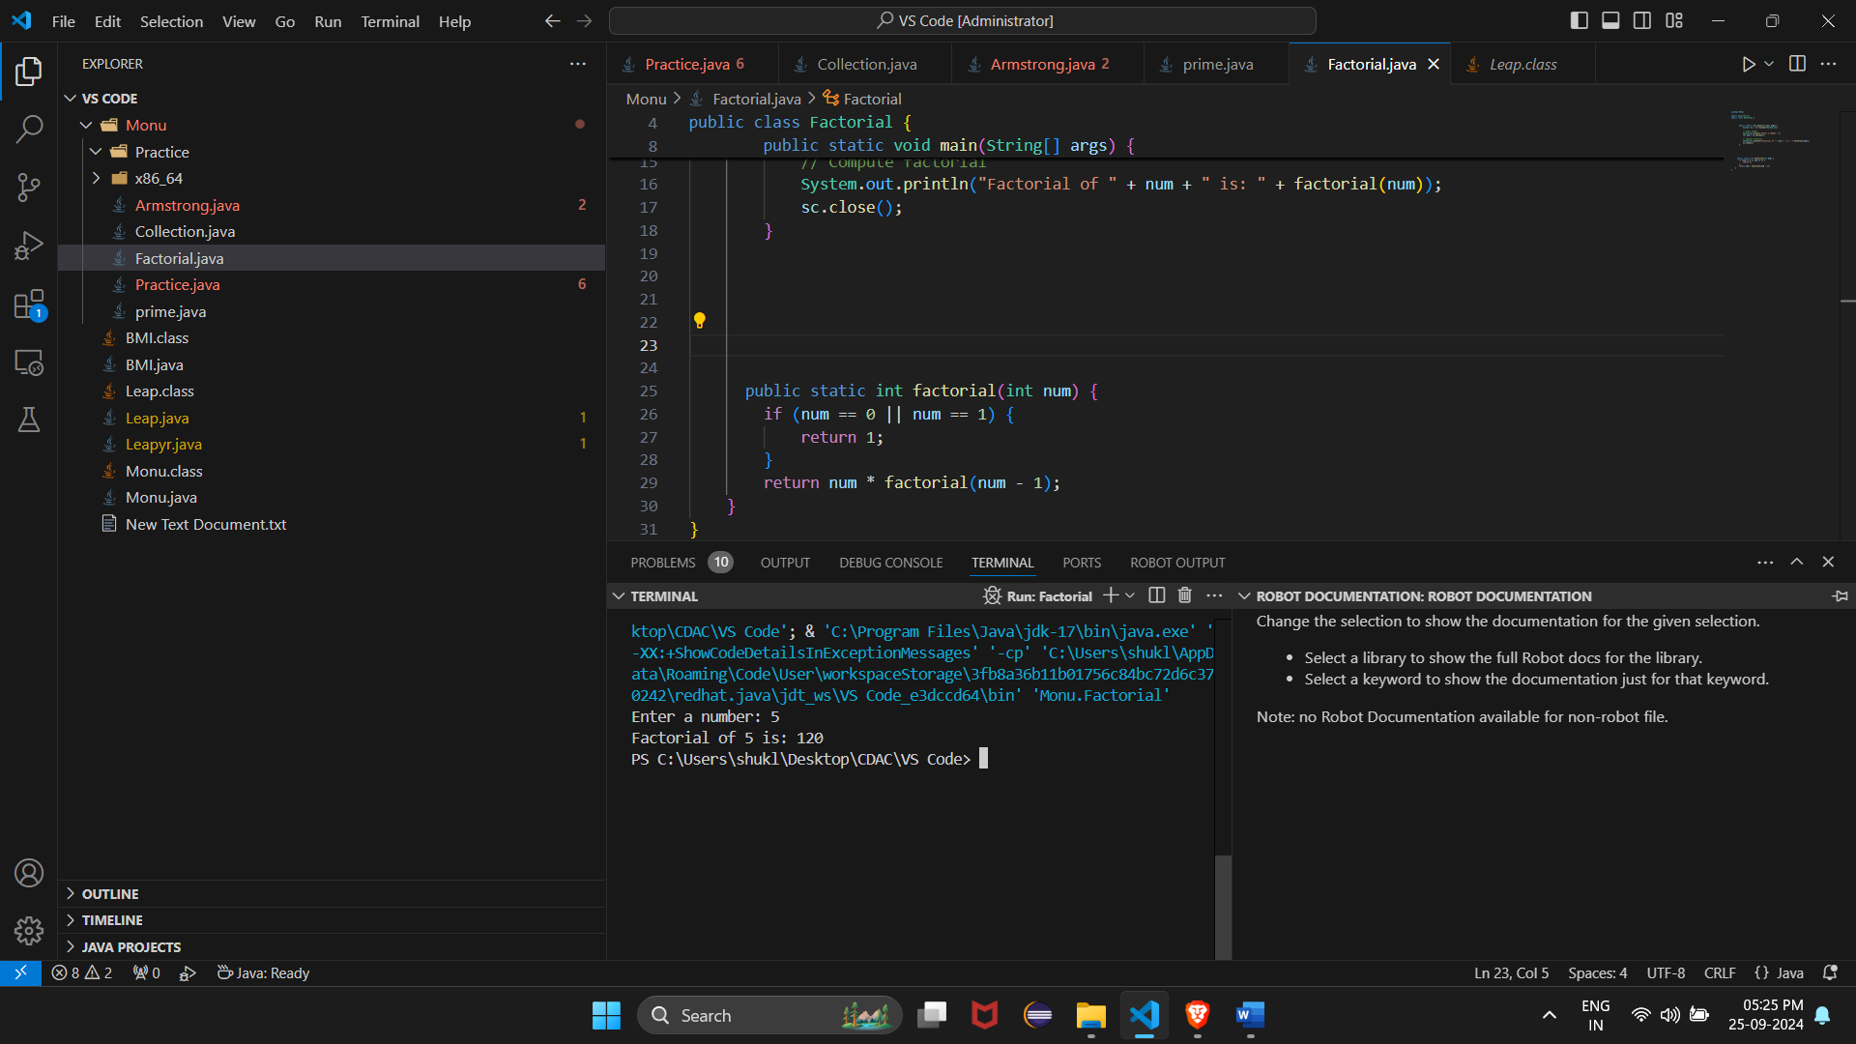

4. Fibonacci Series

Problem: Write a Java program to print the first n numbers in the Fibonacci series.

Test Cases:

Input: n = 5

Output: [0, 1, 1, 2, 3]

Input: n = 8

Output: [0, 1, 1, 2, 3, 5, 8, 13]

Code: import java.util.Scanner;

public class Main {

public static void main(String[] args) {

// Create a scanner object to read input

Scanner sc = new Scanner(System.in);

// Ask the user to input an integer N

System.out.println("Enter any integer:");

// Read the input from the user

int N = sc.nextInt();

// Function Call to print Fibonacci series

Fibonacci(N);

// Close the scanner

sc.close();

}

// Method to print the Fibonacci series up to N terms

public static void Fibonacci(int N) {

int first = 0, second = 1;

// Print the first two Fibonacci numbers

System.out.print("Fibonacci Series: " + first + " " + second);

// Loop to generate the rest of the series

for (int i = 2; i < N; i++) {

int next = first + second;

System.out.print(" " + next);

first = second;

second = next;

}

System.out.println(); // Move to the next line after printing

}

}

***Time Complexity:*** *O(N)****Auxiliary Space:*** *O(1)*

5. Find GCD

Problem: Write a Java program to find the Greatest Common Divisor (GCD) of two numbers.

Test Cases:

Input: a = 54, b = 24

Output: 6

Input: a = 17, b = 13

Output: 1

Code:

public class Main{

public static void main(String[] args)

{

int Num1=12, Num2=8, Temp, GCD=0;

while(Num2 != 0)

{

Temp = Num2;

Num2 = Num1 % Num2;

Num1 = Temp;

}

GCD = Num1;

System.out.println("\n GCD = " + GCD);

}

}

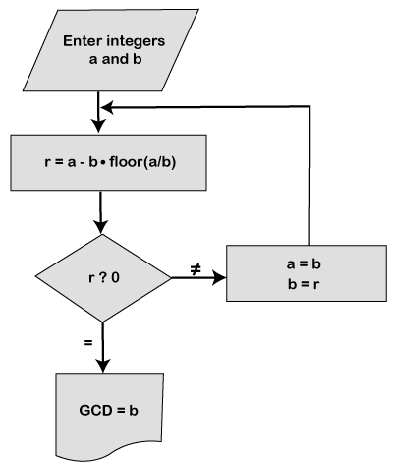

6. Find Square Root

Problem: Write a Java program to find the square root of a given number (using integer approximation).

Test Cases:

Input: x = 16

Output: 4

Input: x = 27

Output: 5

Code:

import java.lang.Math;

class Main {

// driver code

public static void main(String args[])

{

double a = 30;

System.out.println(Math.sqrt(a));

a = 45;

System.out.println(Math.sqrt(a));

a = 60;

System.out.println(Math.sqrt(a));

a = 90;

System.out.println(Math.sqrt(a));

}

}

7. Find Repeated Characters in a String

Problem: Write a Java program to find all repeated characters in a string.

Test Cases:

Input: "programming"

Output: ['r', 'g', 'm']

Input: "hello"

Output: ['l']

Code:

import java.util.*;

public class Main {

public static void main(String arg[]) {

String str = "beautiful sea";

char[] carray = str.toCharArray();

System.out.println("The string is: " + str);

System.out.print("Duplicate Characters in above string are: ");

for(int i =0 ;i<str.length();i++){

for(int j=i+1 ; j<str.length() ;j++){

if(carray[i] == carray[j]){

System.out.print(carray[j] + " ");

break;

}

}

}

}

}

* Convert the given string into character array.
* Run the outer for loop from **index 0** to length of character array.
* The inner for loop will run from **current+1** index to length of the character array.
* Next, we use **if block** to check whether current character is equal to the next character.
* If found equal, print the duplicate character.

The time complexity of this algorithm is **O(n²)**

The space complexity is **O(n)**

Start

↓

Input String "beautiful sea"

↓

Convert String to char[] array

↓

Outer loop: i = 0 to n-1 (length of string)

↓

Inner loop: j = i+1 to n

↓

Compare array[i] == array[j]

↓Yes ↓No

Print array[j] Move to next character

↓

Continue until all characters checked

↓

End

8. First Non-Repeated Character

Problem: Write a Java program to find the first non-repeated character in a string.

Test Cases:

Input: "stress"

Output: 't'

Input: "aabbcc"

Output: null

Code:

import java.util.HashMap;

import java.util.Scanner;

public class Main {

public static void main(String[] args) {

Scanner sc = new Scanner(System.in);

System.out.print("Enter a string: ");

String str = sc.nextLine(); // Read the input string

HashMap<Character, Integer> charCount = new HashMap<>();

// Count occurrences of each character

for (int i = 0; i < str.length(); i++) {

char currentChar = str.charAt(i);

charCount.put(currentChar, charCount.getOrDefault(currentChar, 0) + 1);

}

// Find the first non-repeated character

char firstNonRepeated = '\0'; // Default value to indicate no non-repeated character found

for (int i = 0; i < str.length(); i++) {

if (charCount.get(str.charAt(i)) == 1) {

firstNonRepeated = str.charAt(i);

break; // Stop at the first non-repeated character

}

}

// Output the result

if (firstNonRepeated != '\0') {

System.out.println("The first non-repeated character is: " + firstNonRepeated);

} else {

System.out.println("No non-repeated characters found.");

}

sc.close(); // Close the scanner

}

}

Start

|

V

Input String (str)

|

V

Create a HashMap to store character counts

|

V

For each character in the string:

|--> Increment count in HashMap

|

V

For each character in the string:

|--> If count == 1, return as first non-repeated character

|

V

If no non-repeated character found, return null

|

V

End

**Time Complexity:**

* **O(n)**:

**Space Complexity:**

* **O(k)**:

9. Integer Palindrome

Problem: Write a Java program to check if a given integer is a palindrome.

Test Cases:

Input: 121

Output: true

Input: -121

Output: false

Code:

import java.util.Scanner;

public class PalindromeCheck {

public static void main(String[] args) {

Scanner sc = new Scanner(System.in);

System.out.print("Enter an integer: ");

int number = sc.nextInt(); // Read the input number

int original = number; // Store the original number

int reversed = 0; // Variable to store the reversed number

// Reverse the number

while (number > 0) {

int digit = number % 10; // Get the last digit

reversed = reversed * 10 + digit; // Build the reversed number

number /= 10; // Remove the last digit from number

}

// Check if the original number is equal to the reversed number

if (original == reversed) {

System.out.println(original + " is a palindrome.");

} else {

System.out.println(original + " is not a palindrome.");

}

sc.close(); // Close the scanner

}

}

**O(d)** where d is the number of digits in the number.

**O(1)** since it uses a constant amount of space.

**Explanation:**

1. **Input**: The program prompts the user to enter an integer.
2. **Reversal Logic**: It uses a while loop to reverse the number by extracting the last digit and building the reversed number.
3. **Comparison**: After reversing, it compares the original number with the reversed number.
4. **Output**: The program outputs whether the number is a palindrome or not.

10. Leap Year

Problem: Write a Java program to check if a given year is a leap year.

Test Cases:

Input: 2020

Output: true

Input: 1900

Output: false

Code:

import java.util.Scanner;

public class LeapYear {

public static void main(String[] args) {

Scanner sc = new Scanner(System.in);

// Input year

System.out.print("Enter a year: ");

int year = sc.nextInt();

// Check and print if it's a leap year

if (isLeapYear(year)) {

System.out.println(year + " is a leap year.");

} else {

System.out.println(year + " is not a leap year.");

}

sc.close();

}

public static boolean isLeapYear(int year) {

// Leap year conditions

if (year % 4 == 0) {

if (year % 100 == 0) {

if (year % 400 == 0) {

return true

Top of Form

Bottom of Form